**DAILY ONLINE ACTIVITIES SUMMARY**

|  |  |  |  |  |  |  |  |  |
| --- | --- | --- | --- | --- | --- | --- | --- | --- |
| **Date:** | **27/06/2020** | | | | | **Name:** | **V ANJANA PAI** | |
| **Sem & Sec** | **IV sem & B section** | | | | | **USN:** | **4AL18CS094** | |
| **Online Test Summary** | | | | | | | | |
| **Subject** | | **DATA COMMUNICATION** | | | | | | |
| **Max. Marks** | | **30** | | **Score** | | | **15** | |
| **Certification Course Summary** | | | | | | | | |
| **Course** | **Blockchain Basics** | | | | | | | |
| **Certificate Provider** | | | **Greatlearning academy** | | **Duration** | | | **2.5hours** |
| **Coding Challenges** | | | | | | | | |
| **Problem Statement1:**  Write a C program to print kth digit. | | | | | | | | |
| **Status: Executed** | | | | | | | | |
| **Uploaded the report in Github** | | | | | **YES** | | | |
| **If yes Repository name** | | | | | **lockdown-coding** | | | |
| **Uploaded the report in slack** | | | | | **YES** | | | |

Online Test Summary: 18CS46 test was scheduled from 11:30am t0 12:00pm. The portion for the IA was 5th module there were 30 questions and the time assigned was 30 minutes the questions were mcq type.

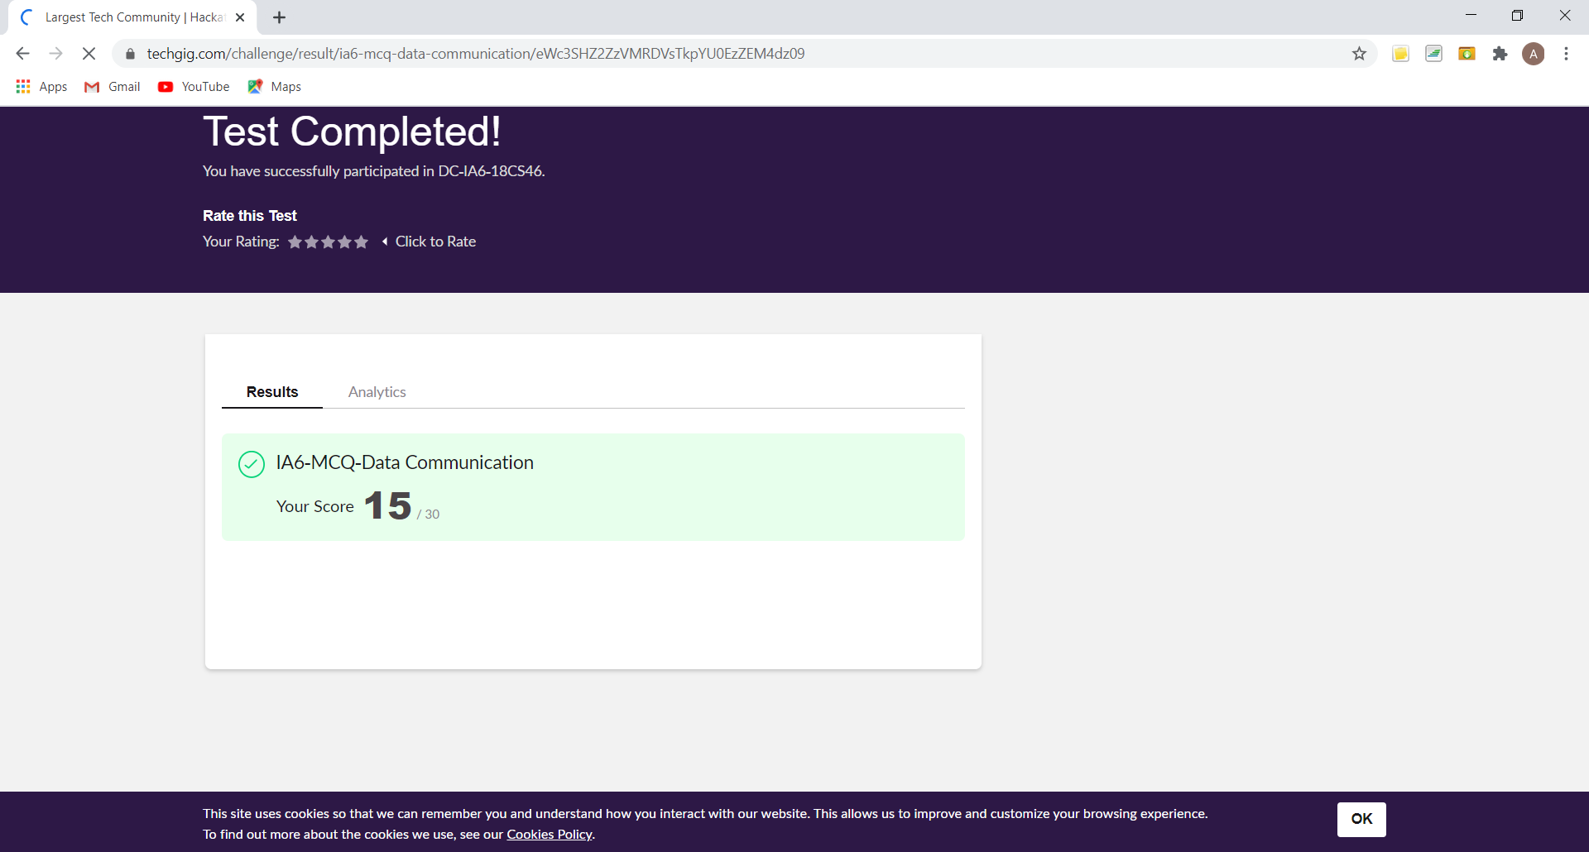

This is the snap shot of completion of test and the marks obtained in 18CS46.

Online Certification Course Summary: In today’s session I have learnt about Proof of Work and Stake.

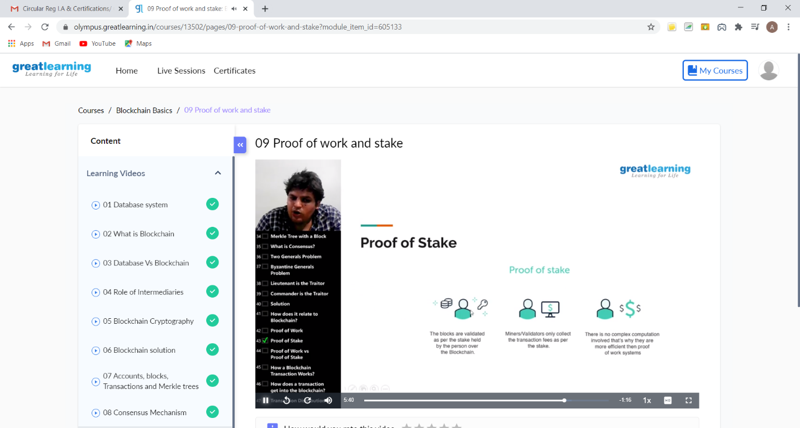

This is the snap shot of today’s session.

Online Coding Summary: **Today I had received one program from prof. Shilpa CSE Dept.The program is mentioned above in the coding challenges(pg.01). I have also uploaded it to my Github repository.**

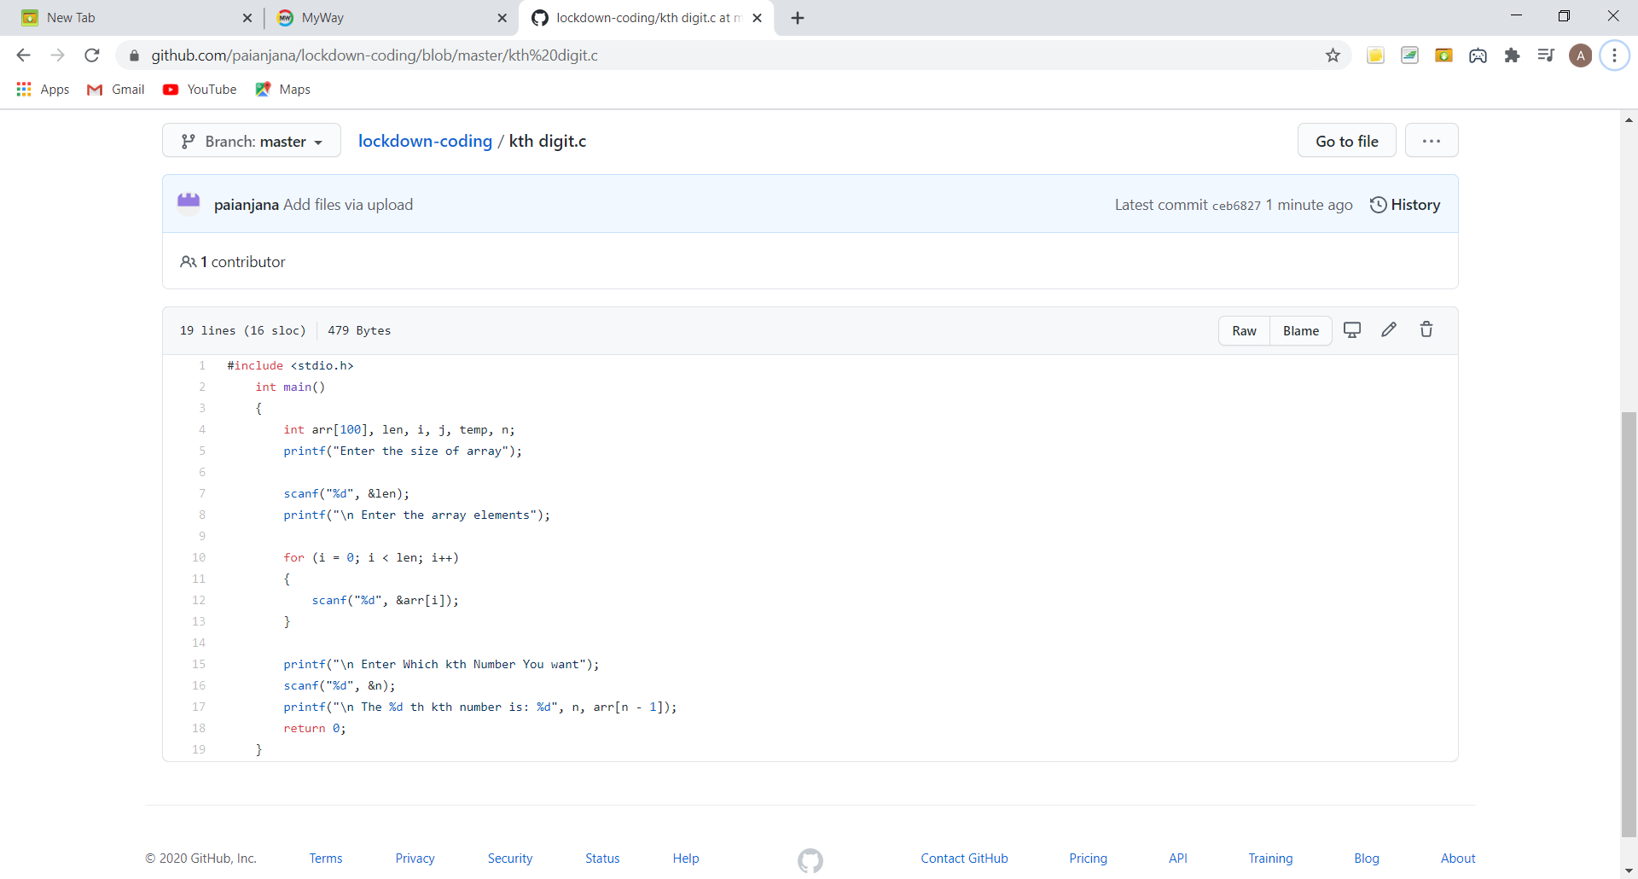

**This is the snap shot of my GitHub repository** where I have uploaded the code. File name is kth digit.c

Online Training: Today I couldn’t attend the online training session due to the internet issues.